**Sorting Application:**

The application is used to get Random number from Rest Service and Sort in ascending order by using another Rest Service. This Application also shows the number of position changed to get in Ascending order.

This application will also show the previous history of Numbers sorted.

**Prerequisites**

The Sorting Front End UI should be up and Running fine to test the application.

The Front End UI is available in the below git repository.

**GitURL:** [**https://github.com/pvimalmec/Sorting-App-UI.git**](https://github.com/pvimalmec/Sorting-App-UI.git)

The Rest services should be up and Running fine to test the application.

The backend service is available in the below git repository.

**GitURL:**  <https://github.com/pvimalmec/Sorting-App-BackEnd.git>

**Integration Test Results:**

Step1: when the user clicks http://localhost:4200.It will be redirected to home page

**Home Screen:** 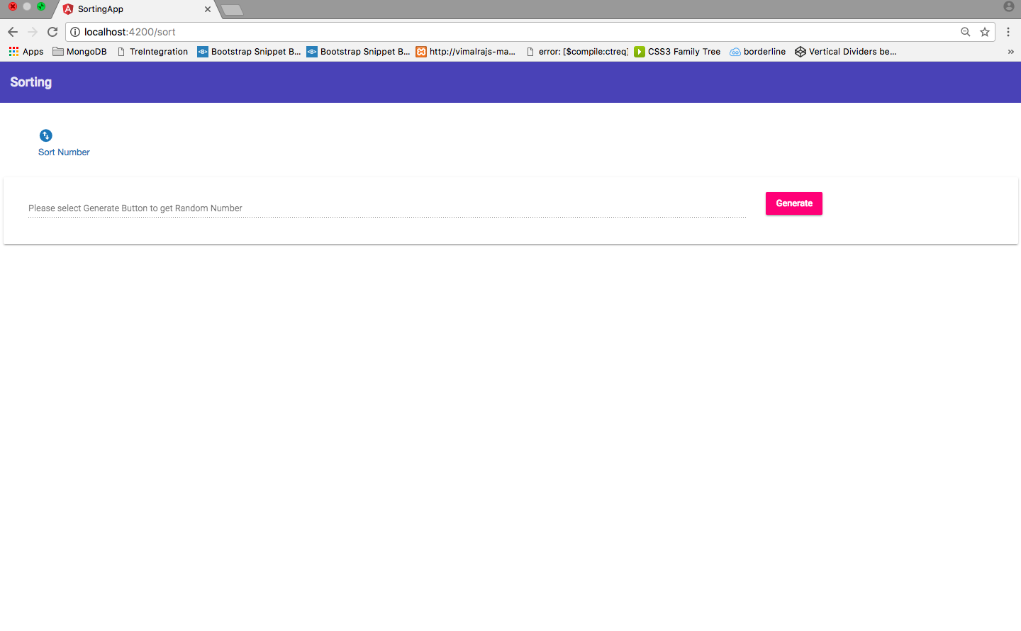

Step 2. In home screen, Sort Number hyperlink will be available, when user click on the link, it will be redirected to <http://localhost:4200/sort>

Step3: Please select the Generate button and it will generate 10 random numbers and the Click Sort Now button will be visible.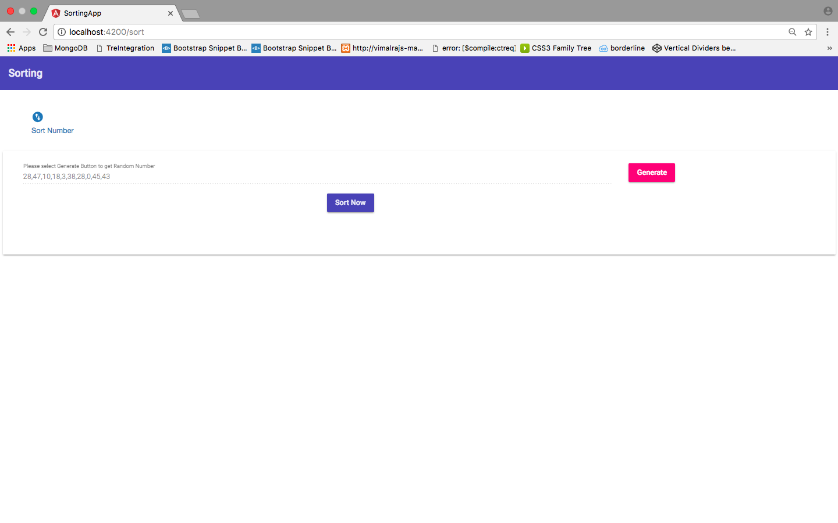

Step 4: Please Select Sort Now button, the Sorted numbers in ascending order will be populated.

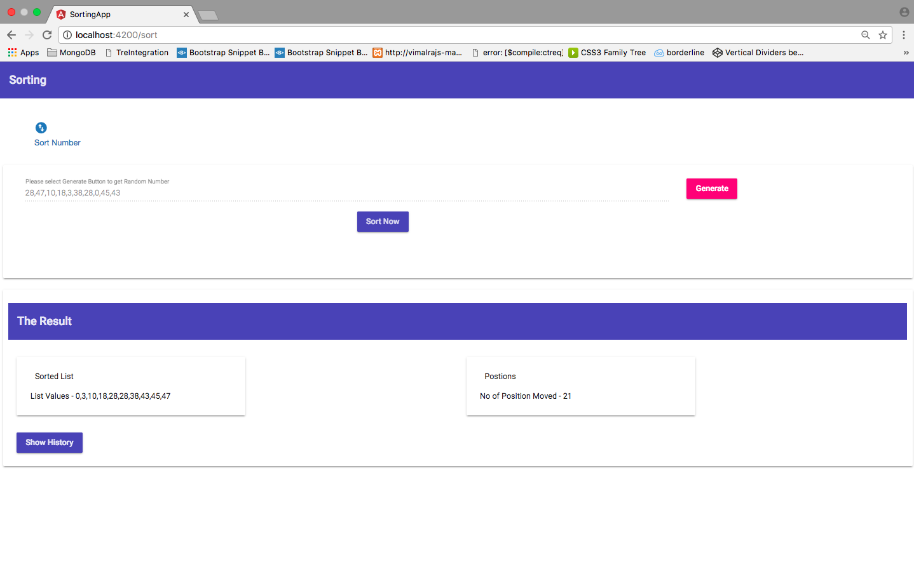

Step 5: To Know the History of Previous Sorted Values. Please Click on the Show History Button.

